# Homework 1 – Rui Qin 30874157 Studio 25 Mon 18:00

## Task 1 - Chartjunk (1%)

Starting with Sheet 1, multiple adjustments were introduced to enhance its effectiveness. Initially, the 3D effects applied to the bars were eliminated, facilitating improved visibility and comparability among the data points. Gridlines, which added unnecessary complexity, were subsequently removed, leading to a cleaner background and reduced visual clutter. The removal of the distracting background colour allowed the data itself to become the focal point of the visualization.

To enhance comprehension, the legend was substituted with annotations placed directly on the chart. The text labels along the axes were enlarged, leading to enhanced legibility and easier reading. As part of the effort to streamline the visualization, the secondary axis, which didn't contribute significant value, was removed. Additionally, the trend line, not relevant in this context, was eliminated. In the pursuit of a more coherent representation, the bars were reorganized in descending order, resulting in a clearer presentation of data. Annotations were standardized in terms of format, providing consistency throughout the visualization. The title was similarly revised to conform to the established format across the entire dashboard.

Similar changes have been made in sheet 2. Annotations were homogenized in terms of format, and the title was adjusted to match the uniform format adopted throughout the dashboard. The distracting background colour was eradicated, allowing the data to stand out more effectively. Furthermore, label adjustments were implemented to express percentages of the total, aiding comprehension for viewers.

Turning to Sheet 3, a series of modifications were carried out to improve its visual impact. Annotations were standardized and adjustments were made to the title to adhere to the consistent formatting principles across the dashboard. To reduce visual clutter, redundant annotations were removed. Similarly, unnecessary shading was expunged, enhancing the overall visual clarity of the sheet.

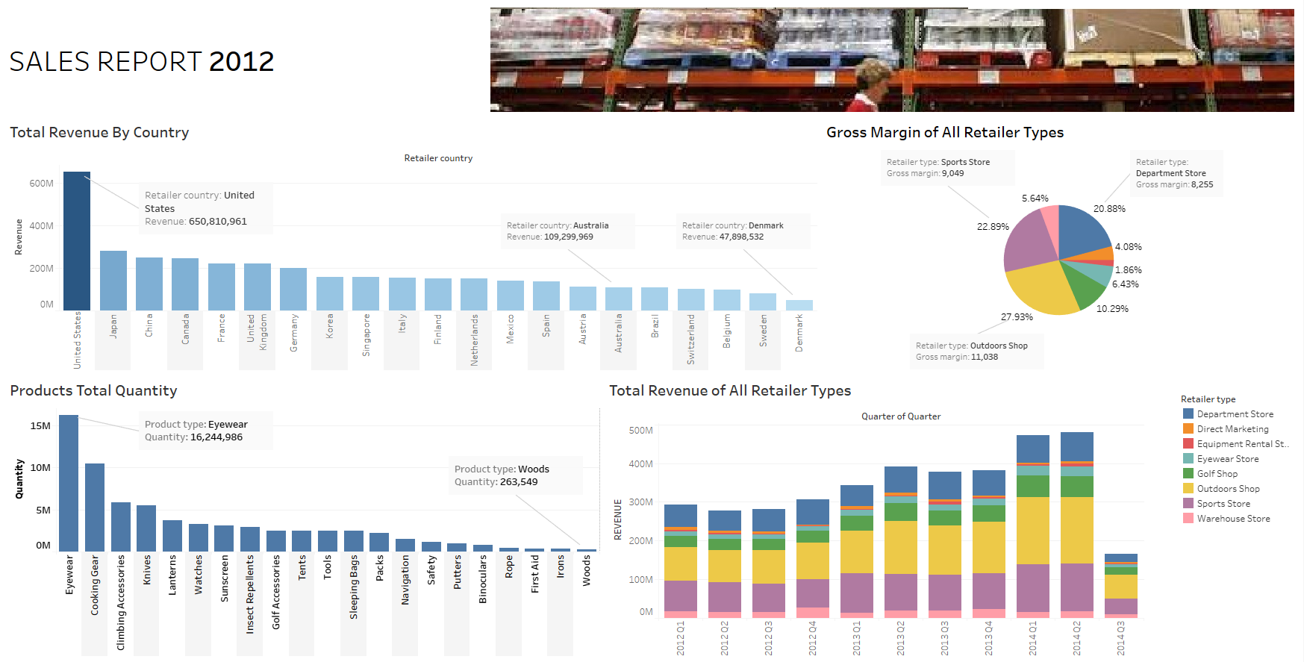Lastly, Sheet 4 received attention. The line chart was replaced with a more appropriate visualization type, aligning the representation more closely with the data's nature. By resetting borders to their default settings, visual simplicity was emphasized, bolstering the clarity of the chart.

## Task 2 - Colour, Layout and Typography (1%)

The initial dashboard layout lacked coherence and suffered from scattered elements, impeding focused engagement. To improve overall readability, I streamlined the layout for better comprehension. Notably, I compacted the layout to mitigate the absence of margins, which previously contributed to a cluttered appearance. By thoughtfully positioning the "Source" information at the bottom, I achieved a visually balanced layout.

Typography played important role in refining aesthetics and legibility. The previous mix of fonts resulted in a cluttered look; I addressed this by adopting a consistent font, ensuring a polished and harmonious visual style. I refined typeface, weights, and font sizes to enhance readability. Larger fonts for titles and subtitles commanded attention, while smaller text within the map and diagram maintained a balanced visual hierarchy.

The original dashboard's diagram lacked depth and failed to highlight key trends. To address this, I introduced annotations within the line chart to emphasize intriguing patterns. These annotations pinpointed the year of Florida's population peak and highlighted Florida on the chart, enhancing user understanding. Colour adjustments were pivotal to enhance the visual experience; complementary colours established a clear hierarchy, facilitating data comprehension.

The colour palette in the initial version was diverse, potentially overwhelming users. In response, I adopted a restrained and harmonious colour palette to create a unified appearance, fostering a more comfortable viewing experience. Furthermore, I tackled text readability concerns by optimizing text and background colours to ensure easy reading, effectively addressing issues of poor contrast.

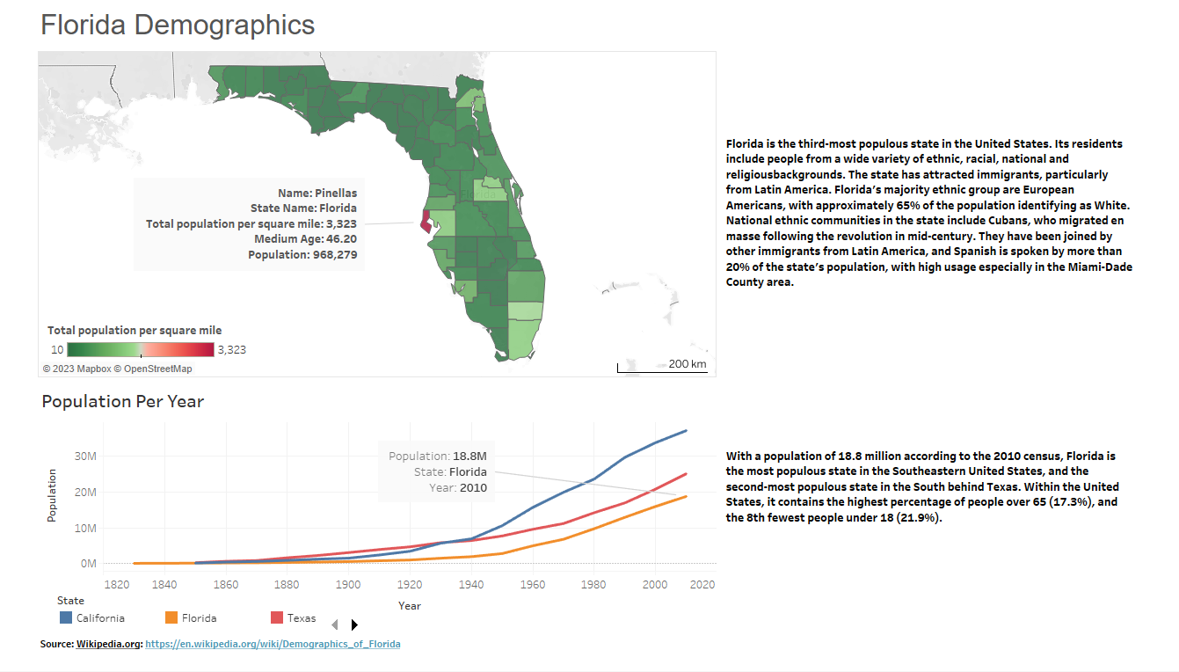The tooltip underwent a significant redesign to enhance data comprehension. Through left-aligned text and consistent font sizes, I facilitated effortless scanning. Abbreviations were replaced with full metric names, contributing to user-friendly information dissemination. Overall, these changes culminated in a refined dashboard, offering improved coherence, enhanced aesthetics, and better data communication.